Ailartsua Adventurer’s Guide
Written and designed by David Hoctor

Index:
Geography
Player Species
Religion
Languages
Games
Calendar
Settlement Hierarchy
Money
Healing
Living Expenses
Potions and Oils
Selling Items
Travel Speeds
Communication
Exhaustion
House Rules
Enhancing Immersion

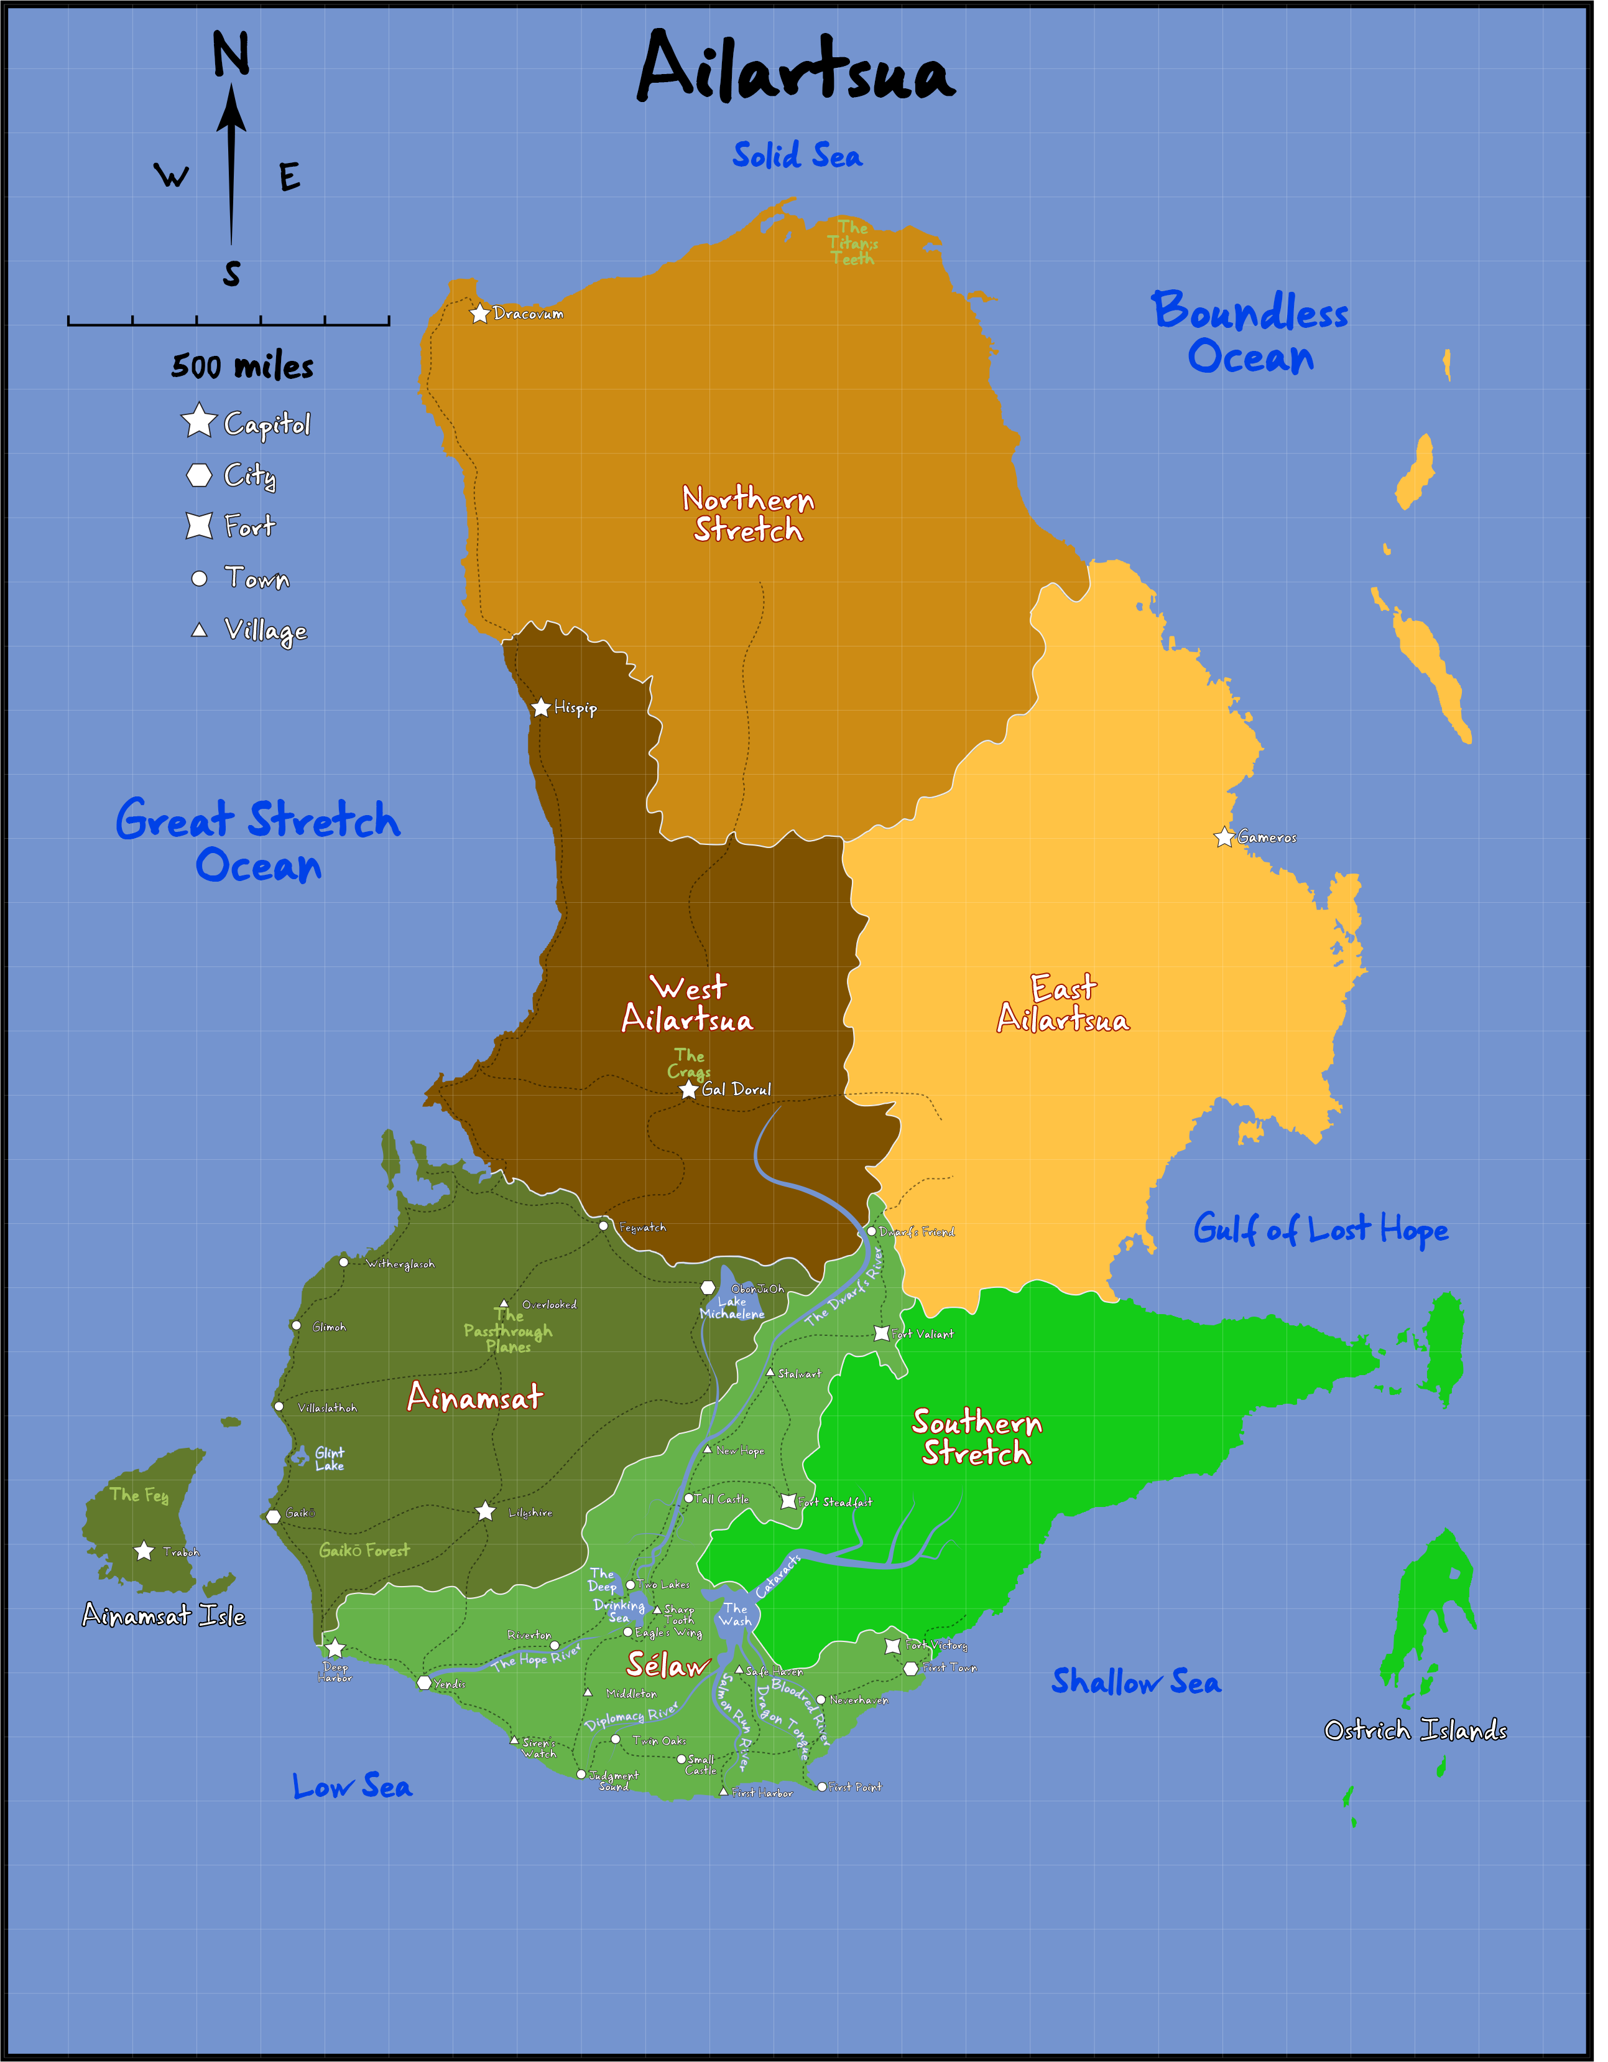
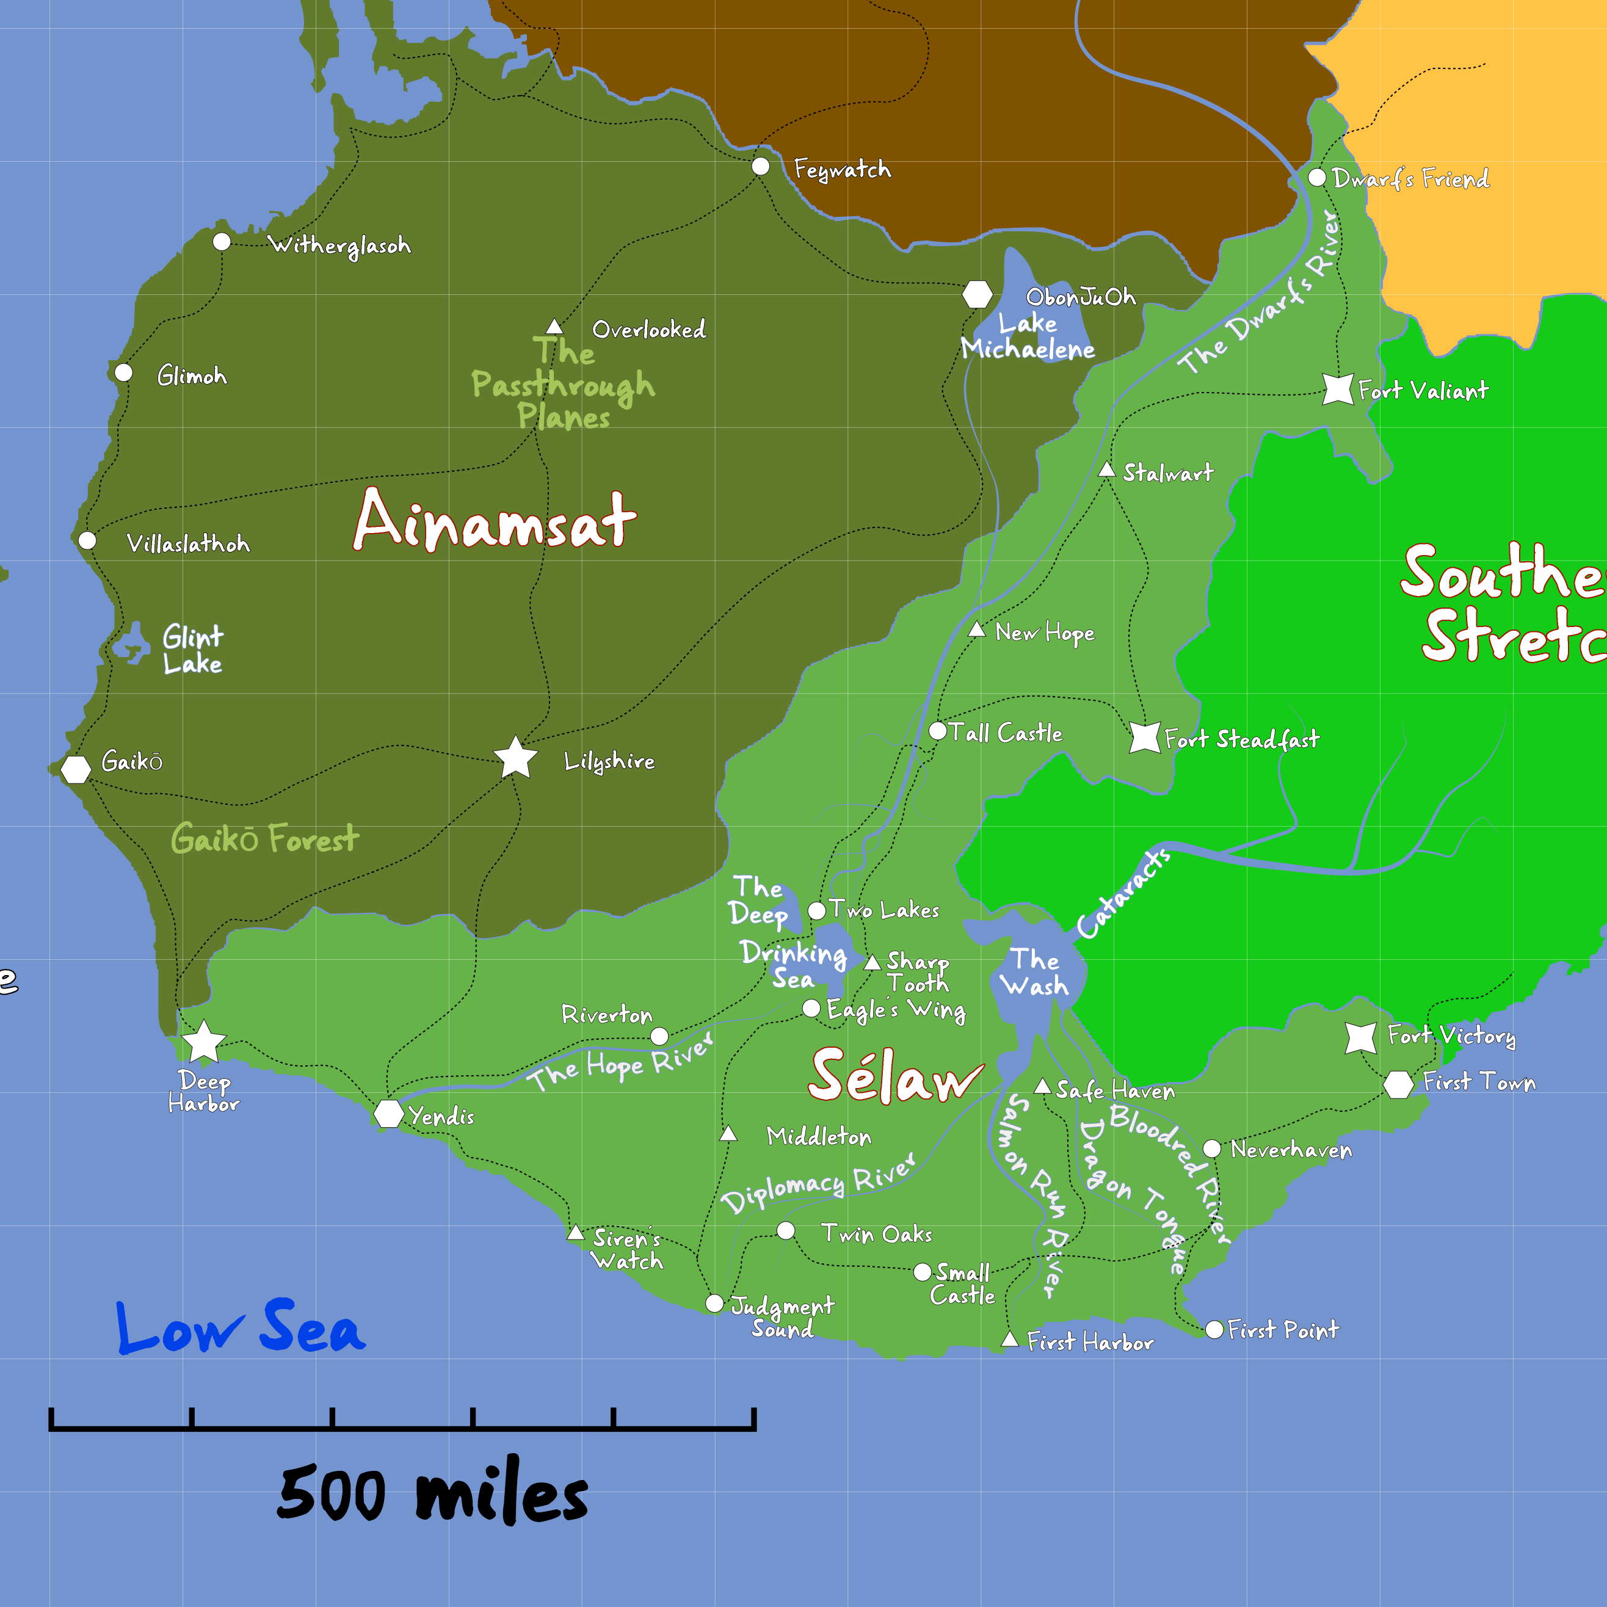

Welcome to Ailartsua!
“The Hoarfrost Invasion” takes place on the continent of Ailartsua. Ailartsua is the largest of two continents on the planet Hahanarudaichi “Mother Earth”, known as Haha for short.

Geography
Ailartsua spans 2500 miles north to south and 2100 miles west to east. The continent is divided into six kingdoms:
- Sélaw (southernmost kingdom)
- Ainamsat (southwest)
- West Ailartsua (center west)
- East Ailartsua (center east)
- The Northern Stretch (north)
- The Southern Stretch (southeast)
It is bordered by two great oceans and three seas:
- The Great Stretch Ocean (west)
- The Boundless Ocean (east)
- The Solid Sea (north)
- The Low Sea (southwest)
- The Shallow Sea (southeast)

Kingdom of Sélaw

Location and Species:
This is the kingdom where “The Hoarfrost Invasion” campaign begins. Sélaw occupies the southernmost region of Ailartsua. It is the cultural and military bastion of Humans. While many species reside here, Aasimar, Goliath, Dragonborn, and Tieflings are rarely seen and are often spoken of in myth.

Military:
- 12,000 active troops (3000 soldiers and 9000 archers)
- 700 naval vessels and local militias
- Military presence has been severely reduced due to deployments in the north, leaving the kingdom increasingly vulnerable to incursions from the Southern Stretch.

Economy:
An agrarian economy bolstered by abundant natural resources:
- Grains: barley, corn, oats, rice, rye, and wheat
- Fruits: avocado, banana, cocoa, coconut, grapefruit, lemon, mango, orange, papaya, and pineapple
- Livestock: cattle, goat, pig, poultry, and sheep
- Dairy: cattle and goat
- Fishing: both freshwater and saltwater industries

Demographics:
Represented Species: Predominantly Human, followed by:
- Dwarves
- Halflings
- Elves
- Gnomes
- Orcs
Cities: There are two main types of cities in Sélaw; agrarian/merchant based and Forts. Deep Harbor is the capital and largest city. Yendis is the region’s second largest city followed by First Town, Fort Steadfast, Fort Valia, and Fort Victory. The forts were once bastions protecting the region from The Forsaken invasions coming out of the Southern Stretch kingdom. Those invasions ended over a century ago, so the Forts have become more agrarian/merchant focused as well. Unfortunately, the Forts did not maintain their defensive structures over the years. This combined with the fact that much of the military forces having been sent North, the Southern Stretches have become emboldened and have begun their raids again.

Geography:
- Northern Sélaw: dense forests and rolling hills
- Western Sélaw: expansive plains, wooded areas, and gentle hills
- Southeastern Sélaw: warm plains transitioning into tropical zones

History:
Sélaw was once part of the Southern Stretch and inhabited by The Forsaken. The Human settlers of Sélaw were refugees fleeing from Tiefling captivity and the harsh deserts of Eastern Ailartsua into the Northern part of the Southern Stretch, eventually displacing The Forsaken there. After nearly a century of conflict, the Dwarves, weary of Forsaken raids, allied with the Humans to drive the Forsaken into the significantly smaller area that is now considered the Southern Stretch.

Rule:
Sélaw is governed by a co-monarchy:
- King Byron III (Human)
- Queen Brianna III (Human)

Deep Harbor, Capital of Sélaw:
Known As: The City of Everything

Cityscape and Society:
Where the Great Stretch Ocean meets the golden shores of Sélaw, the city of Deep Harbor rises, a gleaming metropolis of white marble towers, bustling merchant ports, and hanging gardens. Known as the City of Everything, it is a thriving confluence of invention, artistry, and ambition. Its sprawling harbor docks ships from every known sea, and above it looms the majestic Crown Citadel, home to the royal family. A sprawling palace crowned with stained-glass domes and draped in the banners of every district.

Culture and Influence:
Innovation is the city’s heartbeat, home to world-renowned academies, libraries, artisan workshops, and magical laboratories. Deep Harbor leads the realm in invention, diplomacy, and exploration. Lanterns throughout the city glow with stabilized blue arcane energy an early product of the kingdom’s famed Blue Flame Scholars.

Unique to this City:
Every autumn, Deep Harbor hosts a spectacular celebration known as the Everything Market. The city transforms into a kaleidoscope of color and chaos. Entire neighborhoods rearrange themselves to accommodate endless stalls, stages, bazaars, and pavilions, welcoming visitors from every kingdom to trade, perform, and celebrate. Each year, the market showcases new marvels of invention, exotic wares, and cross-cultural celebrations.

Yendis, Trade Center of Sélaw:
Known As: The City of Mirrored Shores

Cityscape and Society:
A fortified port city divided into East and West by the wide and steady Hope River. The river flows from the mountains of Northern Sélaw and empties into the Low Sea, carrying goods, stories, and travelers to Yendis. Three tall bridges span the river, evenly spaced from north to south, serving as vital arteries of commerce and connection. Each side of the city has developed its own character: the East is known for its bustling markets and shipyards, while the West holds the guild halls, noble estates, and the city’s oldest neighborhoods. Yendis thrives on order and movement, its streets alive with the sounds of trade and tide.

Culture and Influence:

Trade is the heart of Yendis. Its coastal location and access to the Hope River make it the primary hub of commerce in Sélaw. Merchants from across the continent dock here, exchanging goods from distant lands and turning Yendis into a patchwork of cultures, languages, and traditions. The city council is dominated by merchant guilds, and even the City Watch answers, in part, to trade interests. Festivals in Yendis often honor deities of fortune, wind, and safe passage.

Unique to this City:
Every spring, as the thaw from the northern highlands begins, Yendis holds the Festival of the First Flow. At sunrise on the day the first major trade barge of the season reaches the city, flower petals are scattered from all three bridges into the river, symbolizing prosperity and safe passage for the year ahead. Lanterns are floated at dusk, and a great riverfront banquet is held that spans both sides of the city. It is the only day of the year when tolls are suspended, and the bridges are open all night.

Kingdom of Ainamsat

Location and Species:
Ainamsat located in the southwestern region of Ailartsua, is the homeland of Elves and Halflings. The mainland serves as a bridge to the other kingdoms, where Elves engage in diplomacy and trade. Halflings formally fall under the Elves rule, yet they follow no set political structure and for the most part, just go about their daily lives oblivious to any political machinations.

Ainamsat Isle is reserved for Elves and fey alone and is closed to all non-fey species.

Military:
- 20,000 troops (4000 soldiers and 16,000 archers)
- 400 naval ships and regional militias
- Military forces have been significantly reduced due to the northward campaign.

Economy:
A blend of agrarian and mineral wealth:
- Mining: gems and iron
- Grains and nuts
- Fruits: apple, blueberry, cherry, cranberry, peach, pear, plum, pomegranate, strawberry
- Livestock: cattle, goat, pig, poultry, and sheep
- Dairy: cattle and goat
- Fishing: predominantly freshwater, with limited coastal saltwater trade

Demographics:
Represented Species: Predominantly Elves and Halflings, followed by:
- Humans
- Dwarves
- Gnomes
- Goliaths
- Orcs
Cities: Yōsei No Sekai the capital located on Ainamsat Isle. Gaikō, Secondary Capital located on the mainland. Lilyshire is third largest city.

Geography:
Ainamsat is dominated by lush ancient forests and rolling hills, with mist-covered glades and deep-rooted groves forming natural boundaries.

History:
Much of Ainamsat’s deeper history is discovered as the campaign unfolds.

Rule:
Governance is shared between the Monarch and a Council of Elders:
Queen Tenshi “Angel” (Elf), a wise and gentle ruler who resides in the Capital on Ainamsat Isle.

Council of Elders:
Kōmyō "Bright Wisdom" (Elf) – a wise strategist and advisor who sees the path ahead with clarity.
Gekko "Moonlight" (Elf) – a mystical, enigmatic figure, a master of secrets and magic.
Hayate "Swift Wind" (Elf) – A warrior and scout, known for their speed and decisive action.
Hibana "Spark" (Elf) – a passionate and fiery diplomat, full of energy and inspiration.
Shizuku "Dewdrop" (Elf) – a serene and gentle sage, an expert in healing and nature magic.
Reika "Elegant Flower" (Elf) – a noble and refined advisor, embodying grace and wisdom.

Yōsei No Sekai, Capital of Ainamsat:
Known As: The City of Fairies

Cityscape and Society:
The city of Yōsei No Sekai “Fairy World” is the true capital of Ainamsat is hidden deep within the fey-blessed Ainamsat Isle. Its beauty is legendary but rarely witnessed by non-fey eyes. It is home to the Queen and her Council of Elders. It is a mystical and breathtaking flow of nature and architecture that blends seamlessly with the nature of the isle. Canopies of glowing leaves form natural roofs over spiraling towers and suspended walkways. The city is protected by powerful enchantments and divine pacts.
Culture and Influence
Yōsei No Sekai is the heart of elven identity and spiritual life. It is both sanctuary and stronghold, housing sacred groves, ancestral shrines, and centers of high learning in nature and magic.
Unique to This City
The city itself is a living organism. Certain trees hum with emotion, and seasonal changes affect city functions. Every solstice, the city sings—a ritual blend of magic, music, and memory said to renew the land’s bond with the feywild.

Gaikō, Secondary Capital of Ainamsat:
Known As: The City of Diplomacy

Cityscape and society:
Nestled in a luminous valley lined with silver-leaf trees and crystal brooks, Gaikō, known as the City of Diplomacy, is unlike any other capital. Open to the skies and unguarded by wall or gate, it radiates the calm assurance of a people who trust in beauty, balance, and reason.
Built with harmony in mind, the city’s architecture flows with the land, buildings of sculpted alabaster and living trees curve along carefully planned paths. Elven sky gardens float on motes of magic and the air smells of tea, fresh earth, and lilac. Occasional Halfling burrows that pepper the city, bloom with mosses, pipevine, and morning lilies.

Culture and Influence:
Despite its openness, Gaikō is the political powerhouse of the continent. The Hall of Accord, a serene domed building of polished blue-glass, is where emissaries from all races gather to settle disputes and form treaties under the watchful guidance of Mayor Meiyu, whose title “Sworn Friend” speaks more to deeds than bloodline.
Council members, chosen from Elf circles, and an occasional halfling or two, represent interests ranging from feywild relations to agricultural law. Outsiders often forget, beneath the city's gentle demeanor lies a masterclass in subtle power and long-game politics.

Mayor:
Meiyu "Sworn Friend, Ally" is the city’s ruler and diplomat to the other kingdoms– an elf dedicated to forming lasting alliances among the other species. They are greatly assisted by their council members.

Council Members:
Nagomi "Harmony, Tranquility, or Peace" (Elf) – has a strong sense of calm, balance, and diplomacy, dedicated to fostering peace and understanding among different species.
Ensei "Distant Sincerity" (Elf) – Fosters long-term, genuine relationships between species.
Chōwa "Harmony, Balance" (Elf) – Emphasizes the role of maintaining equilibrium and cooperation.
Sajō "Left Acceptance" (Elf) – Understands different perspectives and fostering compromise.
Kenshō "Wise Auspice" (Elf) – Their wisdom brings good fortune and peaceful resolutions.
Meiyu "Sworn Friend, Ally" (Elf) – Dedicated to forming lasting alliances.
Mathew Wildhair (Halfling)- Often drifts off to sleep when the conversation goes beyond what was had for breakfast but does offer uncanny insight when awake.

Unique to this City:
Gaikō hosts the Festival of Accord each spring, where representatives from across Ailartsua perform rituals of peace beneath the Moonblossom Tree. It is said that if the blossoms fall during a treaty signing, the accord will hold for generations.

Kingdom of West Ailartsua

Location and Species:
West Ailartsua is situated in the center-west of the continent. It is home to a triad of dominant peoples: Dwarves dwell deep within mountains and elder forests, Gnomes populate the coastal cliffs and younger wooded regions, and Goliaths reside in the towering peaks and alpine ranges.

Military:
- 30,000 combined forces: 20,000 Dwarves and 10,000 Gnomes
- 50 naval vessels
- Goliaths contribute through tribal warriors and irregulars
- Like other kingdoms, troop numbers are declining as reinforcements head northward

Economy:
West Ailartsua thrives through mining and metallurgy:
- Minerals: gold, silver, precious gems, and rare ores
- Agriculture: grains and apples, especially in lower regions
- Livestock: lamb, pig, and goat
- Dairy: goat and yak
- Fishing: coastal and freshwater

Demographics:
Represented Species: Predominantly Dwarves and Gnomes, followed by
- Goliaths
- Halflings
- Elves
- Humans
- Orcs
Cities: There are two main types of cities in Sélaw; agrarian/merchant based and Forts. Gal Dorul and Hispip.

Geography:
Southern hills rise into northern mountains. The landscape transitions from fertile valleys to snow-capped summits, with rocky coastlines and evergreen forests.

History:
More of West Ailartsua’s history will be revealed throughout the campaign, including tensions between mountain and coastal cultures.

Rule:
Governed by a Dual Monarchy/Diarchy:
Tetsuki "Iron Princess" (Dwarf)- A fierce and commanding leader who is renowned for their strength, resilience, and battle prowess. They are responsible for the Military rule and command.
Chisei “Governance through Wisdom” (Gnome)- Highly respected for their intelligence, diplomacy, and skillful leadership in ruling. They are responsible for Civil administration.
Goliaths maintain tribal independence and recognize no formal sovereign beyond their tribal chiefs.

Gal Dorul, Dwarf Capital of West Ailartsua
Known as: The Iron Crown

Cityscape and Society:
Built high in the heart of the Ironspike Mountains, Gal Dorul does not sprawl, it descends. Carved into the living mountain over generations, it is a marvel of engineering, boasting halls so vast they host their own echoing weather. Grand stairways connect levels lit by volcanic crystal lanterns, and ancient stone guardians watch the gates. It is a city of stone and steam, whose halls ring with song and steel.

Culture and Influence:
At the peak sits the Throneforge, a colossal chamber said to have been carved with the help of elemental giants, where Queen Tetsuki, known as the Iron Princess, commands with unmatched will. Her rule is ironclad and absolute, tempered by years of warfare and industry. Dwarves revere her as a living symbol of strength; Gnomes respect her for allowing innovation to thrive.
The deeper levels of Gal Dorul house the Molten Markets, great open pits and forge plazas where artisans test their mettle against the mountain. Gnomish inventors here build delicate mechanisms with wild flair, while Dwarven smiths hammer out blades and armor fit for gods. Travelers come for weapons, relics, and the legendary brews served in stone-carved taverns echoing with song.

Unique to this City:
Sealed beneath Gal Dorul lie ancient vaults, some sealed since the First Era. The ancient relic troves they house are fiercely guarded by the Vaultguard, a militant order sworn to defend both treasure and memory.

Hispip, Gnome Capital of West Ailartsua
Known as: The Cliff City

Cityscape and Society:
Hispip clings to a towering oceanside cliff. Balconies and spiral lifts adorn its rockface, leading to colorful chambers carved behind waterfalls and sea-blasted stone. Gnomes move about in air gliders and elevators powered by clockwork and waterwheel magic.

Culture and Influence:
Under Chisei’s leadership, Hispip serves as the kingdom’s heart of invention and scholarship. Laboratories and academies are tucked behind garden-covered terraces, and vibrant trade fairs spill from cliff ledges to floating platforms.

Unique to this City:
Each spring, the Gnomes of Hispip release a flotilla of glowing seed lanterns onto the sea during the Festival of Blooming Sparks, believed to carry their dreams and inventions into the stars.

Kingdom of East Ailartsua
Location and Species:
East Ailartsua lies in the center-east of the continent. It is the main bastion of Orcs and Tieflings, whose heaviest populations reside mostly along the coast. The rugged and dangerous frontier west of the coastline is dominated by beasts, bandits, and monsters of all kinds. Many of The Forsaken species are also scattered throughout its harsher lands.

Military:
- 20,000 troops (15,000 soldiers and 5,000 arcane archers)
- 1,000 naval ships
- The region maintains a strong militia presence in its fortified ports and trading posts

Economy:
Primarily agricultural with strong desert-adapted crops:
- Cacti and succulents: agave and prickly pear
- Root crops: beets, carrots, radishes, and turnips
- Fruits: dates, fig, and melon
- Livestock: goat and poultry
- Dairy: camel, goat, and horse
- Fishing: saltwater focused

Demographics:
Represented Species: Predominately Tieflings and Orcs, followed by:
- Dragonborn
- Dwarves
- Gnomes
- Humans
Cities: Gameros

Geography:
Expansive desert and rugged highlands. Rocky terrain, volcanic formations, and deep canyons define the land.

History:
More of the region’s tumultuous past and infernal legacies will be uncovered throughout the campaign.

Rule:
Governed by a Militaristic Monastic Order:
Great Commander Asmodian, the supreme authority over the militaristic side.
Gesmena and Balefina hold authority over the monastic order that governs law, trade, and magic.

Gameros, Capital of East Ailartsua:
Known As: The City of Gold and Fire

Cityscape and Society:
Obsidian spires rise above massive basalt walls etched in infernal glyphs, Gameros stands as a blazing jewel on the eastern coast of Ailartsua, a city where ambition burns as hot as the volcanic forges beneath it. Known far and wide as the City of Gold and Fire, Gameros is a proud, radiant capital, dominated by Tiefling heritage yet bustling with every kind of folk imaginable.
The Great Commander’s Keep, perched on a sheer cliff above the harbor, is a sprawling fortress-palace of blackened stone and red crystal. Its towers burn with eternal flames, a magical beacon seen from leagues across the sea. The royal triad, Great Commander Asmodian and his two co-ruling Queens, Gesmena and Balefina, govern with both passion and cunning, their court a place of intrigue, seduction, and spectacle.
Within the high walls, Gameros is a riot of color, flame, and shadow. Tiered districts climb the hills, each more opulent than the last. The Infernal Quarter near the docks, pulses with life, a maze of spice-laden markets, foreign tongues, and fire dancers performing amid flickering everflames. Here, Tiefling traditions run deep, devil-masked festivals, street duels of honor, and whispered pacts made under crescent moons.
The Ember Arcades serve as the city's financial heart, gilded halls of trade where merchants broker deals worth kingdoms. Banks, vaults, and auction houses line the golden boulevards, protected by elite Tiefling enforcers and Orcish mercenaries clad in ash-steel armor.
Despite its infernal ties, Gameros is not unwelcoming, only intense. Non-Tieflings, especially Orcs, have found great opportunity here. Many Orcs serve as soldiers, engineers, and builders, giving strength and structure to the city's flame-born elegance.

Culture and Influence
Art and culture thrive in the city like nowhere else. The Furnace Theatres feature illusionist plays and fire-dancer ballets, and the Gallery of Ash and Ember displays works from across the continent, some of which are said to be alive or cursed. Music drifts from balconies and temple steps, blending infernal harmonics with foreign styles in haunting beauty.
Gameros’ influence extends well beyond its walls. As the eastern coast’s most important port, its exotic markets draw traders from the desert nations to the south, jungle isles to the east, and even the distant sky cities of the north. If it can be bought, bargained, or stolen, it passes through Gameros.

Unique to this city:
Beneath its glorious surface lies a deeper current of arcane secrecy. The city’s oldest catacombs predate the Tiefling dynasty and are rumored to be guarded by ancient contracts never broken. The Magisterium Ignis, a Tiefling-led arcane cabal, governs magical study and enforces strict control over summoning magic, though rumors persist of firebound demons walking freely among the city’s elite.
Worship is diverse, though infernal patrons are especially venerated. Shrines to devils of knowledge, wealth, and ambition are common, but so too are hidden altars to forbidden gods and dark spirits, tucked away in alley sanctuaries or beneath black market halls.

Northern Stretch
The Northern Stretch spans the frozen peaks of the continent’s north. It is the main bastion of Aasimar and Dragonborn. Virtually no signs of The Forsaken are found here and very few Humans or Halflings either. Dragonborn Capital City: Dracovum.

Military:
- 30,000 troops, primarily Dragonborn and Goliath warriors
- 50 naval vessels for coastal defense
- Forces are strained by ongoing battles with the Hoarfrost invasion

Economy:
Heavily reliant on mining and high-altitude agriculture:
- Minerals: gold, platinum, silver, and rare ores
- Livestock: yak, reindeer, goat
- Grain and hardy root vegetables
- Fishing: freshwater and glacial lakes

Demographics:
Represented Species: Predominantly Dragonborn, followed by:
- Gnome
- Goliath
- Tiefling
- Elf
Cities: Most cities are collections of towers with aeries.

Geography:
Steep, frozen mountains with deep valleys and icy cliffs. Most settlements cling to ledges, cliff faces, and natural perches.

History:
The region is steeped in divine mystery and celestial prophecy, much of which will be uncovered as the campaign progresses.

Rule:
Divine Monarchy:
King Shamut (Dragonkin), Commanding leader who is rumored to have direct ties to Bahamut.

Dracoven, Capital of The Northern Stretch:
Known As: The City of Skyfire

Description:
Atop the jagged frost-blasted peaks of the Northern Stretch, the towers of Dracoven rise like the spines of a slumbering wyrm. Dracoven is not a city in the conventional sense, rather, it is a collection of stone towers, walkways, and aerial platforms connected by magic and wind-carved bridges. Each tower serves a purpose: governance, worship, training, prophecy.

Cityscape and Society:
The air itself thrums with elemental power, and lightning is often seen dancing across the stone towers without harm. King Shamut, a towering silver-scaled Dragonborn, is said to commune directly with Bahamut and acts as both ruler and oracle. He is flanked by his Skyseers, blind sages who read omens in flame, smoke, and lightning.

Cultural Influences:
Dracoven’s influence is spiritual as much as political. Many travel here not to trade, but to seek purpose. The cold tests the body, the thin air tests the will, and the fire within, that is what makes one worthy in the eyes of the Dragonborn.

Unique to this city:
The highest aeries are sacred, they are the Temples of Flame and Sky, where ancient rites of breath and blood are performed. Outsiders are rarely permitted entry, but those who do are often changed, blessed, cursed, or marked by divine forces. Once a year, during the Ascension Moon, chosen pilgrims attempt the Trial of Wings, a ritual climb where only those deemed worthy may speak with the divine.

Southern Stretch
The Southern Stretch encompasses the humid southeastern wilderness of Ailartsua. It is the chaotic and ungoverned domain of the Forsaken, beings cast out from the other kingdoms and forged by blood, bone, and fire.

Military:
- Estimated forces range from 10,000 to 100,000
- Loose warbands, raiding parties, and beast-mounted battalions
- No central command, but immense regional power

Economy:
Driven by conquest and trade in forbidden or stolen goods:
- Raiding and pillaging of other kingdoms
- Trade of relics, exotic herbs, cursed items, and ancestral bones
- Independent jungle markets occasionally offer rare wares to brave traders

Demographics:
Represented Species: Bugbears, Goblins, Gnolls, Hobgoblins, Kobolds, Lizardfolk, Ogres, Sahuagin, Worg, etc.

Cities:

Geography:
Thick jungles, steaming swamps, tangled mangroves, and hidden ruins. Paths change with storms and spirits, and nothing remains still for long.

History:
Once part of the ancestral lands of many now-exiled peoples, the Southern Stretch became a haven for the forsaken and outcast after centuries of conflict with the central kingdoms. Its true history is mostly oral and deeply spiritual.

Rule:
There is no centralized government. Tribal chieftains, warlords, and spirit-bound shamans govern scattered strongholds. Authority is earned through strength, mysticism, or divine favor.

Capital City:
No capital marks the Southern Stretch, and no road truly claims it. Here, goblins, ogres, lizardfolk, and other Forsaken dwell in shifting allegiances, hidden jungle strongholds, and forgotten ruins of civilizations swallowed by time. It is a place of raw, living wilderness, where the gods of tooth, claw, and storm still walk in spirit.

Each tribe holds its own lands by strength, cunning, or rite. Power is ephemeral, and so is peace. Yet, some whisper of a loose council of shamans who gather at the Stone Maw, a cavern-temple of ancient prophecy where lava meets ocean deep beneath the earth.

Unique to this Region:
While not unified, the Southern Stretch is not without culture. Their bonecraft, skin inking and scarring, and drum rituals are older than any recorded history of the other five kingdoms. Traders brave enough to venture into the jungle return with rare herbs, soul-binding stones, and sometimes prophecies too old to be understood. The region’s shamans claim to hear the whispers of gods long buried beneath the earth.

Player Species

The First Eight
Dragonborn, Dwarf, Elf, Gnome, Goliath, Halfling, Orc, and Tiefling.

The Last Born
Humans.

The Outliers
Aasimar, Firbolg, Kenku, Tabaxi, and Triton.

The Forsaken (a.k.a. The Halted, Green Skins, Greenies, The Base, The Depraved, The Vile, etc.)
Bugbears, Goblins, Gnolls, Hobgoblins, Kobolds, Lizardfolk, Ogres, Sahuagin, Worg, etc.

The Nine
Dragonborn, Dwarf, Elf, Gnome, Goliath, Halfling, Orc, Tiefling, and Human. Used by Humans and The Forsaken, who both include Humans with The First Eight.

Interactions Between Species
Apart from The Forsaken, all species mentioned above, for the most part, accept and tolerate each other with little to no bias. General racial opinions of note:
- Orcs do face some standoffishness due to their close ties with The Forsaken. Elves and Humans are the guiltiest of such bias. The situation improves every generation, unfortunately Elves have very long generations.
- Many Elves, particularly those isolated on Ainamsat Isle, view themselves as superior to other species, often thinking of humans a slight grade above the Forsaken. That aside; Elves still tend to treat other species with respect.
- Although Elves and Dwarves have a mutual respect for each other’s craftsmanship, many Dwarves feel there is little skill put forth by elves in their forging as it is guided more by magic than by muscle. Dwarves are particularly off put when Elvish architecture is lauded by others, especially if equal credit is not given to their functionally superior and perfectly constructed edifices.
- In Sélaw and the Southern Stretch, Aasimar, Dragonborn, Goliaths, and Tieflings are almost things of myth, as they are rarely seen there. Dragonborn are often met with awe and Tieflings with fear.
- Aasimar are rare and considered a gift no matter the species they show up in.
- Dragonborn have a long-lasting relationship with the Gnomes. The serious, stoic, and driven Dragonborn are drawn, mostly out of curiosity, to the quirky, emotive, lighthearted Gnomes.
- Outliers are rare in all areas.
  - Tabaxi are almost never seen outside the coastal areas of Ainamsat and Sélaw and are generally met with curiosity.
  - Aasimar are almost exclusively in the Northern Stretch. Met with Awe.
  - Firbolg tend mostly to West Ailartsua. Met with nervous curiosity.
  - Kenku settlements, though rare, can be found anywhere in Ailartsua. Met with great mistrust.
  - Triton settlements, though rare, can be found just off any coast of Ailartsua. Met with awe and great curiosity.
  - The Forsaken tend to meet The Nine with violence and warlike tendencies. They run frequent raids into Sélaw and West Ailartsua from The Southern Stretch and East Ailartsua.

Species’ Origins
Humans are still in their infancy from Hahanarudaichi’s standpoint. Humans have only had traditional cities, education and commerce for a thousand years or so. The older species are still trying to find a comfortable arrangement with their new short-lived siblings.

Origin History
What follows is a brief overview of the origin and history for the major species of Hahanarudaichi.
When some of the major species came into existence on Hahanarudaichi:
- Elves and Dwarves 500,000 years ago
- Gnomes and Halflings 400,000 years ago
- Dragonborn and Goliaths 350,000 years ago
- Orcs and Tiefling 250,000 years ago
- Aasimar and Humans 3000 years ago
- Many species came in through with the Fey 500,000 years ago and through the dimensional rift with the Tieflings 250,000 years ago. The species that accompanied the Tieflings battled and evolved into many of the species known as The Forsaken. Some of The Forsaken were the result of The Experimental Age; born of Elfish and Tiefling magic and experimentations.

Emergence Cycles
Origin of Dwarfs: Starting 600,000 years ago, for a period of 100,000 years Hahanarudaichi created Dwarven broods at her core. These broods consisted of Dwarven nymphs that would slowly journey to her surface through strength and wit. Over the span of 100,000 years these nymphs slowly transformed as they journeyed to Hahanarudaichi’s surface; metamorphosed into their current forms. Hence, their very close bond with the earth.
Origin of the Elves: They entered Hahanarudaichi through the fey 500,000 years ago, just as the Dwarves were emerging from the earth.
Origin of Gnomes: Having created the stoic and sturdy Dwarves to clear a path to her surface, Hahanarudaichi then created the more lighthearted Gnome broods at her core. The Gnome nymphs used many of the Dwarven paths to Hahanarudaichi’s surface where, at the end of their journey, they were metamorphosed into their current forms.
Origin of the Halflings: Halflings are the results of early dark Elves magical experimentations on Gnomes.
Origin of Dragonborn: Dragons, extra-planer beings have inhabited Hahanarudaichi for 1,500,000 years. They were slow to study the newly arrived Elves, Dwarves, Gnomes, and Halflings. Once the Dragons eventually took note of the practical benefits of the humanoid form in non-magical feats of engineering and crafting, they created the Dragonborn as their working class.
Origin of Giants: Giants were created by Titans, extra-planer beings. The Titans created them to keep Dragons from claiming all Hahanarudaichi for themselves. For over one and a half million years the two have kept each other in check.
Origin of Goliaths: During the War of the Colossi between Giants and Dragons, the giants created Goliaths to deal with the Dragon’s Dragonborn forces.
Origin of Orcs and Tieflings: Orcs and Tieflings entered Hahanarudaichi through a rift not too dissimilar from the one Yukinba Hoarfrost used in “The Hoarfrost Invasion”. The extra-planer rift was between the infernal planes and this one. Tieflings were escaping persecution and the Orcs a new world to conquer.
Origin of the Humans: Tieflings, wanting to create a less warlike and more subservient race to serve them, used dark interdimensional magics to experiment on Orcs. The result of their dark magics produced Humans. Humans were worked and abused as slaves to the Tieflings for thousands of years. After hundreds of uprisings the Tieflings decided these self-willed creatures were too much to deal with and cast the humans into the deserts to die, but the newly formed race proved tenacious and survived. Over the centuries humans migrated out of the deserts of East Ailartsua and, with assistance from the Dwarves, managed to cut a swath through The Forsaken in the Southern stretch forming the region that is now Sélaw.
Origin of the Aasimar: Dimensional magic energy seeped into this world from the extraplanar rifts of both the Fey and Dark Dimensions of the Tieflings. These energies weave throughout this world occasionally mixing and resulting in an Aasimar being born.

Religion

Inyo (a.k.a. The Ten, The Great Spirits, Balance):
There is but one religion across Ailartsua: Inyo. Inyo centers on the tenet that there are Ten Great Celestial Spirits (Gods), Kotoamatsukami or Koto, that imbue Hahanarudaichi with a balance of divine energy. Their divine energies are tightly knit with the magical energies that suffuse Hahanarudaichi.
The Kotoamatsukami (The Great Celestial Spirits/Gods), Koto for short, are the first gods, they have been in existence since before the creation of the universe. They were never ‘born’, they just are and always have been. Each one reigns over one of the schools of alignment. The Koto are all served by Kami (Great Spirits) who, act as their go between, dealing more directly with mortal and terrestrial issues that the Koto are too far removed from.

The divine energy of each individual Koto aids all life that remains consistently faithful to the precepts of their matching alignment. This aid, although customarily small, may turn the tide of great events.
How a mortal creature lives its life constantly molds and powers its own life energy. When such a creature dies its energy joins that of the Koto of the alignment they best forged through life. The more a creature demonstrates its alignment in life the more powerful this energy. The Kami, in service of their designated Koto, take notice and occasionally reward creatures who have built up large reserves of these energies.
Most followers of any of The First Six (good and neutral) respect followers of any of the other Six, but live their life based on the tenets of their Spirit. The Spirit’s power is ever-present so no one anywhere on Ailartsua doubts their existence or power.

The Kotoamatsukami and their matching Alignments:
Koto Name | Alignment: General Tenet / Loyalties*
Ichi | LG: All life is sacred / Society ≥ Immediate circle ≥ Allies ≥ Others ≥ Self
Ni | NG: Some life is sacred / Self > Immediate circle > Allies > Society > Others
San | CG: Most life is sacred / Immediate circle ≥ Allies >Self> Society > Others
Shi | LN: All Life is respected / Society > Self > Immediate circle > Allies > Others
Go | N: Some life is respected / Self >Immediate circle ≥ Allies≥ Society > Others
Roku | CN: Most life is respected / Self > Immediate circle > Allies > Society > Others
Shichi: | LE: Life has meaning if its needed / Society>Self >Allies>Immediate circle >Others
Hachi | NE: My life has meaning / Self > Immediate circle > Allies > Society > Others
Kyū | CE: Life is profane / Self ∞> Immediate circle > Allies > Society > Others
Jū | Unaligned: Instinct, survival, evolution, continuation of the species: Self > Species
*Society= your particular society/species/region’s laws. Immediate Circle= family & friends.

Jū (Spirit of fauna)
Jū is a spirit whose power is often overlooked. Most don’t consider it when thinking of Inyo, it is surprising how many forget Inyo is “The Ten” and only consider the first nine. Although Jū has no direct influence with ‘sentient species’, its indirect influence can sometimes have the most beneficial or the most detrimental effects. Jū makes no distinction between miniscule single celled protozoa or bacteria, rabbits, elephants, or enormous megalodons. Those that show the strongest will to continue the species are the most noted by Jū.
Kami
Kami are powerful spiritual forces that can take physical form. Their ties to The Koto (The Great Celestial Spirits) are stronger than any other entities found on Hahanarudaichi. They wield the power of The Koto as effortlessly as we lift a fork to eat.

Known Kami

Amaterasu (LG, sun goddess):
Amaterasu is known as the Great Sun Spirit. She is the most powerful Kami and a devout servant and protector of Hahanarudaichi. She is the Koto Ichi’s Archkami.

Sarutahiko Okami (CG, great bright spirit, or greatly virtuous spirit):
Sarutahiko is the Grandson of Amaterasu and the son of Jōshiki. Known as the Great Earth Spirit. He is the Koto San’s Archkami.

Jōshiki, (NG, the spirit of common sense and reason):
Jōshiki is the Son of Amaterasu and the father of Sarutahiko. Known as Jōshiki the Wise. He is the Koto Ni’s Archkami.

Bishamonten (CN, spirit of war):
Bishamonten is one of the Seven Lucky Kami. He is the protector of those who follow the rules and behave appropriately. He protects the treasures of the Kami. He is the Koto Roku’s Archkami.

Yōkai
Yōkai are mischievous and occasionally malevolent lesser spirits that infuse the entire world of Hahanarudaichi. Most consist of broken off or corrupted energy from one of The Koto (The Great Spirits). Yōkai motivations and actions tend toward the alignment of their source Koto. Some are energies of deceased creatures that for one reason or another can’t join with their Koto. Although they come in all shapes and sizes, they all possess the ability to shape shift. They can take the form of almost any creature or inanimate object.

Known Yōkai

Bakeneko (The Cat Lord)
The most powerful of the cat like Yōkai. Bakeneko has evolved over the millennia and has almost achieved Kami status.
Some abilities attributed to Bakeneko: Shapechanging, speaking in all languages, cursing creatures, manipulating the dead, possessing creatures, and controlling packs of wolves. In one popular tale, Bakeneko, desiring a particular prize, Shapechanged into a huge obese Tabaxi to win a wrestling competition. The prize changes with the desired effect of the one telling of the tale.

Nekomata
Cat like Yōkai that typically access the Trickery domain and follow Ni, San, Go, Roku, Hachi, and Kyū.

Tsukimono
Tsukimono are exclusively animal spirits invading human bodies. Tsukimono usually possesses characters only under extreme measures. For example, as an act of revenge; a character killing one of the Yōkai’s children or animals of its domain or destroying its home/haunting (accidently or purposefully). Occasionally they possess for more mundane reasons, for example, a fox Tsukimono may want to eat a delicious pheasant meal it smells so it possesses the diner. The possession is always involuntary on the part of the possessed. No one invites a Tsukimono into his or her body.

Onikuma (Demon Bear)
A bear that has lived for a very long time and transformed into a yōkai. Onikuma continue growing and reach sizes much larger than even the largest natural bears. They walk on two legs and are large enough to carry off cows and horses and can easily move aside boulders than ten men could not budge.

Oni

Yukinba Hoarfrost

The Ancients
Celestial, Dimensional, or Planer beings with exceptionally close ties to The Kotoamatsukami (See Religion section). This includes Angels, Yōkai (spirits), Demons, Devils, etc. Some regions include other beings of great power and longevity in this category, for example, Dragons, Titans, Oni, Giants, etc.

Most Dragons of Hahanarudaichi leave their nests at a young age to travel the planes in a quest of knowledge and treasures, never to return. Those that stay defend their territories with unparalleled ferocity.

Languages
Each race has their own language, for example The First Eight have; Draconic, Dwarfish, Elfish, Gnomish, Goliath (Giant), Halfling, Infernal, and Orcish. Before the birth of humans some representatives of The First Eight Species used a base “Common” language when communicating with each other for trade and treaties. When humans arrived, they took Common as their own. Due to their proclivity for exploration and trade, Humans seem to have had the most, influence on, and interaction with, the other species. Due to this, all other species now learn to speak the “Common” language. This includes many of The Forsaken species that still trade with The First Eight and Humans.

Common colloquialisms

Salutations
- When meeting someone in your home, hosting an event, or in any friendly gathering; people give a quick tight kiss followed with a hug lasting two quick pats on the back.
- When meeting a stranger outside the places listed above, it is common to clasp right forearms and gently rest left hands on each other’s right shoulders; showing both hands are weapon free. If shoulder can’t be reached due to size differences a two-handed clasp is used. If size makes it necessary, it is common for the taller to drop to one knee. If reason for distrust exists, it is common to lift both hands up or manually slide one’s sleeves to elbows displaying bare forearms before continuing with traditional greeting.
- It is common for strangers to bow heads slightly as they pass each other.
- Common: “Well met!” “Good morrow!” “Good day!” “Hail peoples!”
- “I am your servant.” “Your humble servant.” “I bow to you.”
- “We welcome you with open hearts and hearths.” “With open hearts.”
- “I see you.” With the common response being, “I see you too.” (This is a way of saying they recognize you are of the material world, e.g. not an undead or Yōkai.)

Goodbyes
- To a single person: “May your Spirit guide you.”
- To a group: “May the Spirits guide you.” (When plural, most species say “Spirits” rather than “Inyo” as Inyo is used when speaking of all 9 (10) Spirits together. Within close-knit groups you might hear someone reference the person’s individual Inyo, e.g. “May San guide you.”)
  - More formal: “May the Spirits travel ever at your side.”
  - Other versions: “Spirits be with you.” “Spirits protect you.” “Spirits guide you.” “Spirits save ye.”
- “Live another day.” “Until next.” “Go in peace.” “Good journey.” “And now we’re finished.” “Be well.”

Miscellaneous
- Spirit gift (miracle)
- “I’ll [some action] in a mayfly.” For example, “I’ll have that done in a mayfly!” (Referencing the short lifespan of a mayfly.)
- Bellytimber. (Food)
- “She’s got a touch of the Yōkai.” “He’s Yōkai touched.” “Tis luck or Yōkai.” (Used to describe someone who is having a streak of good or bad luck.)
- “Yōkai touched” in the game of Skulls is considered the lucky player, “cursing” the other players, allowing them to win ties. (See Games section below). Can also be used to describe a cursed or haunted item.

Games

Dice

Skulls™ (Skulls & Shields™ in some areas):
The game consists of ten dice and a Skull Token. They can be anywhere from cheap dice and a rock for the Skull token to lavish carved dice and a skull carved gemstone placed in a gilded redwood box. For each die, three of the die faces depict a skull, two depict a shield, and one side is blank. Sometimes there is a board with locations for the five antes.

The game turns are as follows: Cough it up, Hurl, First Skirmish, Cough it up, Second Skirmish, Cough it up, Third Skirmish, Cough it up, Fourth Skirmish, Cough it up, Final Battle.
Rules:
- Cough it up: Players place their ante.
- The Hurl: Each player rolls their 10 dice. Whoever gets the most Skulls places their Skull token in front of them and is now the “Yōkai Touched”. If highest roll is tied, ties reroll until a Yōkai Touched is determined.
- The Skirmish (in some regions called The Rattle): Each player rolls 5 of their dice. Whoever gets most skulls wins the Skirmish. The Yōkai Touched wins any ties. If there is a tie and none of the tied are Yōkai Touched, then ties reroll until there is a winner. Winner becomes the new Yōkai Touched. There is only one Yōkai Touched at a time New Yōkai Touched places their skull stone in front of them, previous picks their skull stone back up.
- Return to Step 1 and play three more times, skipping step 2 each of these times.
  - If a player rolls all five shields they may continue playing without anteing.
  - If a player rolls all five blanks, they must pay double the ante to continue playing.
  - Players may opt to Drop Shield and Run before the next Cough it up and simply bow out leaving their previous antes behind.
- Winner is determined after the Final Battle which is after the fourth Skirmish: Remaining players all Cough it up for the final time and then Hurl all ten dice and the one with the most skulls wins. If there is a tie for first Yōkai Touched wins. If none of the tied are the Yōkai Touched, ties continue to Hurl until there is a winner. Winner takes the pot.

Calendar
Each year is divided into exactly 10 months. Each month is divided into exactly 4 weeks. Each week is divided into exactly 7 days. Hence there are 280 days in a year. The first day of each of the first nine months is a holiday that celebrates the Spirit it is named after. The first six months the celebrations are joyous. The last two months of fall and the first of Winter are solemn celebrations, depicting the death or end of the cycle and the evil alignments of the Koto they are named after. The entire tenth month honors Inyo, balance. The first two weeks in Jūgatsu are spent preparing for the Celebration of Inyo. The celebration of Inyo starts with a huge gift exchanging party on Firstday of the third week of Jūgatsu and the celebrations continue throughout the week. The fourth week of Jūgatsu is spent resting and preparing for the new year.

Months:
Common name | First Eight name
Onemonth | Ichigatsu
Twomonth | Nigatsu
Threemonth | Sangatsu
Fourmonth | Shigatsu
Fivemonth | Gogatsu
Sixmonth | Rokugatsu
Sevenmonth | Shichigatsu
Eightmonth | Hachigatsu
Ninemonth | Kyūgatsu
Tenmonth | Jūgatsu

Days:
Common name | First Eight name
Oneday | Ichiyōbi
Twoday | Niyōbi
Threeday | Sanyōbi
Fourday | Shiyōbi
Fiveday | Goyōbi
Feastday | Rokuyōbi
Peaceday | Shichiyōbi

Seasons:
Common name | The Firstborn name | Begins the first day of
Spring (2 months) | Haru | Ichigatsu
Summer (3 months) | Natsu | Sangatsu
Fall (3 months) | Aki | Rokugatsu
Winter (2 months) | Fuyu | Kyūgatsu

Settlement Hierarchy
Settlements in increasing size:
Stead – A small homestead, usually a single family or a tiny farmstead.
Hamlet – A handful of homes, often centered around a shared resource like a well or a mill.
Thorpe – Slightly larger than a hamlet, often a loose cluster of farms with a small meeting place.
Village – A settled community with a few dozen buildings, typically with a blacksmith, inn, and a small temple.
Hold – A fortified settlement, often ruled by a minor noble or warlord.
Town – A larger, self-sustaining settlement with markets, guilds, and multiple places of worship.
Borough – A town with some form of local governance or autonomy, often walled.
City – A densely populated settlement with extensive trade, multiple districts, and powerful figures of influence.
Metropolis – A sprawling urban center, a hub of commerce, politics, and magical affairs.
Capital – The seat of government for a kingdom or empire, often home to royalty.
Great City – An enormous city of legend, possibly built upon ancient ruins, infused with magic, or an interplanar trade hub.
Megalopolis – A vast, world-spanning city or a collection of cities fused into one massive civilization.
Skyhold/Underkeep – A fantastical city beyond the mundane, such as a floating city, an underground metropolis, or a planar nexus.

Money
1gp=10sp | Gold, silver, and gems are the main currency across Ailartsua. An adventurer may however occasionally come across a region with copper, shells, or other currency, particularly if dealing with The Forsaken and/or The Outliers.

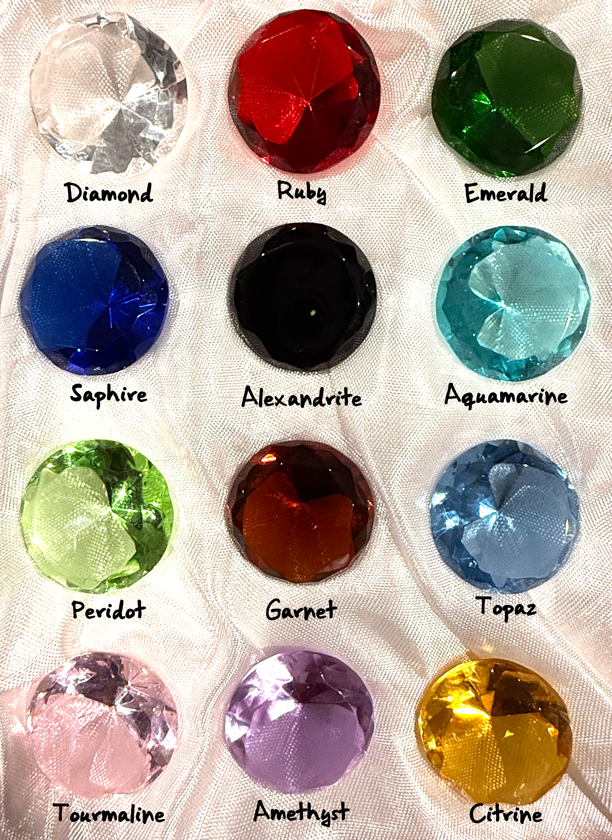
Gems
Name (hue) | Worth*
Diamond (clear) | 10,000 gp
Ruby (Red) | 5000 gp
Emerald (green) | 1000 gp
Sapphire (dark blue) | 750 gp
Alexandrite (dark opaque red) | 500 gp
Aquamarine (light blue) | 250 gp
Peridot (light green) | 100 gp
Garnet (dark red) | 75 gp
Topaz (blue) | 50 gp
Tourmaline (pink) | 25 gp
Amethyst (purple) | 10 gp
Citrine (yellow/orange) | 5 gp
*Giant gems are worth twice the cost listed above, small gems half.

General Costs

Travel
Road Toll: 1 sp per person, 5 sp per wagon/cart without produce or wares, 1 gp per wagon/cart carrying produce or wares.
Gate Toll (Major City): 5 sp per person, 1 gp per wagon/cart without produce or wares, 5 gp per wagon/cart carrying produce or wares.

Land Transport: 1 sp/10 mile
Ship Transport: 1 sp/mile
Flying Mounts: 60’ 30 gp/day + feed | 80’ 50 gp/day + feed | 90’ 100 gp/day + feed. Flying mounts are paid for up front. They are enchanted to return to stable after paid for time expires. They will also return if not fed every morning. Each Wyvern/Griffon requires, at minimum, the haunch of a large fresh, goat, sheep, pony, small deer or equivalent.

Healing
Short Rest: A Healing Kit is needed to use Hit Dice, so characters must stock up on the Components that fill it. A player consumes 1sp of components per Hit Dice for levels 1-5 and 1gp of components per Hit Dice for levels 6+. Players should keep a separate collection of purchased tokens that represent what they have spent on their Healing Kit Components and remove the tokens as the components are used. A typical healing kit contains herbs, animal products, and tools for minor surgeries. All these items are then infused with healing magic.
As a Utilize action, you must expend one of your healing kit components to stabilize an Unconscious creature that has 0 Hit Points.

Here's a more detailed look at what might be included and imbued with magic in a Healing Kit:
- A variety of herbs and spices:
  - Chamomile - for digestion and sleep.
  - Comfrey (Knitbone) - Setting broken bones and healing bruises.
  - Dandelion - snakebite.
  - Garlic - Antiseptic with antibacterial properties.
  - Horehound - coughs and sore throats mixed with honey.
  - Henbane - joint pain.
  - Lavender - Headaches, anxiety, and minor burns.
  - Licorice - Lung problems.
  - Mint - Stomach ailments.
  - Yarrow to stop bleeding and heal wounds.
  - Other plant-based ingredients often used for ointment and broth formulations: bay, bishopwort, celadine, cropleek, cumin, ginger, helenium, hollowleek, pepper, radish, red nettle, rosemary, sage, thyme, and wormwood.
- Bandages & Wound Care
  - Animal Fat or Lard - Mixed with herbs to create healing salves and ointments.
  - Beeswax & Honey - Antiseptics for dressing wounds.
  - Cloth soaked in vinegar - Prevent infection.
  - Dried moss or Sphagnum moss - Natural antibacterial wound dressings.
  - Goose grease or suet - Soothing balms.
  - Linen Strips - bandaging wounds.
  - Powdered bones or crushed pearls - Thicken poultices and pastes.
  - Resin From Pine or Fir Trees - Seal wounds and prevent infection
- Surgical & Medical Tools
  - Bone needles & thread - Stitching wounds.
  - Cupping horns - drawing blood to the surface (bloodletting).
  - Mixing and measuring spoons - combining ingredients for pultices, salves, or potions.
  - Mortar and pestle - Grinding herbs into powders or pastes.
  - Small knives or lancets - Used for minor surgeries.
  - Small sickle - harvesting herbs.
  - Tourniquet rods - tightening tourniquets.
  - Tweezer-like forceps - Removing splinters, shrapnel, and arrowheads.
  - Vials or Containers - storing and mixing potions, tinctures, and other remedies.

Tithing
Traditional- 1 sp Borough or smaller, 1 gp City or larger.

Living Expenses
Inn (room per night/person) | Meal
Flea-infested flophouse: 1sp | Bread and Broth: 1sp
Common: 5sp | Bread, Cheese, Soup: 5sp
Good: 1gp | Bread, Cheese, Meat, Veg 1gp
Excellent: 5gp | Banquet (per person) 10gp
Ale (common/good/excellent) | Wine (common/good/excellent)
Mug 1sp/1gp/5gp | Glass 5sp/1gp/10gp
Pitcher (6 mugs) 5sp/5gp/25gp | Bottle (6 glasses) 25sp/5gp/50gp

Lifestyle Expenses Per Day Between Adventures
- Wretched 0sp
- Squalid 5sp,
- Poor 1gp
- Modest 3gp
- Comfortable 5gp
- Wealthy 10 gp
- Aristocratic ≥20gp

Services Pay
Untrained: 1gp +1sp/level per day= 5gp + 5sp/level per week
Trained: 5gp +5sp/level per day= 25gp + 25sp/level per week
Professional: 10gp +1gp/level per day= 50gp + 5gp/level per week
Identify: level of spell or item x 10gp + 1gp per level of caster.

Markets

Magic Item Costs
Common: 100 gp
Uncommon: 500 gp
Rare: 5000 gp
Very Rare: 50,000 gp
Legendary: 250,000 gp+
Artifact: Priceless

Potions and Oils
Color of Contents | Name & Effect (Effect may automatically be known) | ~ Cost
Flasks Red | Potion of Healing (2d4 + 2) [levels 1-5] | 50 gp
Flasks (Silver) Red | Potion of Greater Healing; (4d4 + 4) [levels 6-10] | 100 gp
Flasks (Gold) Red | Potion of Superior Healing; (8d4 + 8) [levels 11+] | 500 gp
Flasks (White) Red | Potion of Supreme Healing; (10d4 + 20) [levels 15+] | 5000 gp
Orange | Potion of Barkskin; AC can’t be less than 16 for 10 rounds. | 500 gp
Orange/White | Potion of Climbing; 1 hour. | 75 gp
Yellow | Potion of Minor Vitality; Removes one level of exhaustion. | 100 gp
Orange/Yellow | Potion of Vitality; Cures any disease or poison and removes exhaustion. | 50,000 gp
Red/Orange/Yellow | Potion of Firebreath; Target within 30’, 4d6 fire damage, DC 13 Dexterity Save for half. 3 breaths or 1 hour. | 500 gp
Green | Oil of Injury Poison; coats one weapon, ammunition, trap component, and other objects that deal piercing or slashing damage. One time delivery! A creature subjected to Oil of Injury makes a DC 10 Constitution saving throw. On a failed save, the creature takes 6 (2d6) Poison damage and has the Poisoned condition for 24 hours. On a successful save, the creature takes half as much damage only. | 100 gp
Green/Red | Potion of Resistance; Fire for 1 hour. | 500 gp
Green/Yellow | Potion of Resistance; Lightning for 1 hour. | 500 gp
Green/White | Potion of Resistance; Cold for 1 hour. | 500 gp
Blue | Potion of Waterbreathing; Can breathe underwater for 1 hour. | 500 gp
Blue/Orange | Potion of Invulnerability; resist all damage for 1 minute. | 5000 gp
Blue/Yellow | Potion of Speed; Haste 1 minute. | 50,000 gp
Blue/White: | Potion of Flying; 1 hour. | 50,000 gp
Purple | Potion of Giant Strength; Hill Giant 21, 1 hour. | 500 gp
Purple/Yellow | Potion of Giant Strength; Fire Giant 25, 1 hour. | 5000 gp
Purple/White | Potion of Giant Strength; Storm Giant 29, 1 hour. | 500,000 gp
Black | Oil of Slipperiness; Grease Spell 1 hour. | 500 gp
Bottle Black/Yellow | Oil of Sharpness; coats 1 slashing or piercing weapon or 5 slashing or piercing ammunition (+3 Atk and Dam for 1 hour). | 50,000 gp
Bottle Black/White | Oil of Etherealness; Etherealness Spell 1 hour. | 5000 gp

Selling Items
The table below is to be used as a base. DM will adjust depending on the variables surrounding the location. Considerations: on a trade route, types of commerce, current market, overall wealth, etc.
Village | Town | City
Arms/Armor/Equipment  5% | Arms/Armor/Equipment  30% | Arms/Armor/Equipment  50%
Art/Magic/Misc Sundries:  Payment upfront: 10%  or  Wait until sold: 30%  Time needed to sell:  Common: 7 + 1d6 days  Uncommon: 14 + 1d6 days  Rare: 21 + 1d8 days  Very Rare: 28 + 1d12 days  Legendary: n/a | Art/Magic/Misc Sundries:  Payment upfront: 30%  or  Wait until sold: 50%  Time needed to sell:  Common: 1d6 days  Uncommon: 7 + 1d6 days  Rare: 14 + 1d8 days  Very Rare: 21 + 1d10 days  Legendary: 28 + d100 days | Art/Magic/Misc Sundries:  Payment upfront: 50%  or  Wait until sold: 80%  Time needed to sell:  Common: 1d2 days  Uncommon: 1d6 days  Rare: 7 + 1d6 days  Very Rare: 14 + 1d8 days  Legendary: 21 + d100 days

Travel Speeds

On foot
One Round (Tactical) |  |  |  |  | Effect
Speed | 15 feet | 20 feet | 30 feet | 40 feet
Slow | 5 ft. | 10 ft. | 15 ft. | 20 ft. | Can Stealth/Hide
Walk | 15 ft. | 20 ft. | 30 ft. | 40 ft.
Dash | 30 ft. | 40 ft. | 60 ft. | 80 ft. | -5 Perception
One Minute (Local)
Speed | 15 feet | 20 feet | 30 feet | 40 feet
Slow | 50 ft. | 100 ft. | 200 ft. | 300 ft. | Can Stealth
Walk | 150 ft. | 200 ft. | 300 ft. | 400 ft.
Dash | 200 ft. | 300 ft. | 400 ft. | 500 ft. | -5 Perception
One Hour (Overland)
Speed | 15 feet | 20 feet | 30 feet | 40 feet
Slow | ½ mile | 1 mile | 2 miles | 3 miles | Can Stealth
Walk | 1 mile | 2 miles | 3 miles | 4 miles
Dash | 2 miles | 3 miles | 4 miles | 5 miles | -5 Perception
One Day (Overland)
Speed | 15 feet | 20 feet | 30 feet | 40 feet
Slow | 6 miles | 12 miles | 18 miles | 24 miles | Can Stealth
Walk | 12 miles | 18 miles | 24 miles | 32 miles
Dash | 18 miles | 24 miles | 32 miles | 40 miles | -5 Perception

1000 miles:
Average Walk: At 24 miles per day, it takes 40 days.
Military Pace: At 40 miles per day, not so easy, but possible, it takes 25 days.

On Mounts/Vehicles
Mount/Vehicle | Crew | Passengers | MPH | Miles Per Day
Draft horse, Pony, Dog, Donkey, Mule: 40’, 9 hours/day plus two 1-hour rests (one every 3 hours) |  | 1 | 4 | 36
Bear, Camel, Raptor: 50’, 9 hours/day plus two 1-hour rests (one every 3 hours) |  | 1 | 5 | 45
Riding horse, War horse: 60’, 9 hours/day plus two 1-hour rests (one every 3 hours) |  | 1 | 6 | 54
Cart or wagon | 1 | 8 | 3 | 27
Airship | 10 | 20 | 15 | 135
Galley (sailed and rowed) | 80 |  | 4 | 36
Keelboat (rowed/poled, add current if applicable) | 1 | 6 | 1 | 9
Long ship (sailed and rowed) | 40 | 150 | 3 | 27
Rowboat (rowed) | 1 | 3 | 2 | 18
Raft or barge (poled or towed) | 1-4 | 1-10 | 1 | 9
Sailing ship (sailed) | 20 | 20 | 10 | 90
Warship (sailed and rowed) | 60 | 60 | 12 | 108
Hippogriff, Bat: 60’, 9 hours/day plus two 1-hour rests (one every 3 hours) |  | 1 | 6 | 54
Wyvern, Griffon: 80’, 9 hours/day plus two 1-hour rests (one every 3 hours) |  | 1 | 8 | 72
Nightmare, Pegasus: 90’, 9 hours/day plus two 1-hour rests (one every 3 hours) |  | 1 | 9 | 81

1000 Miles on Horseback: Riding or War horse: At 54 miles per day, it takes 18 days.

Communication

Messenger Pigeons
60mph for 600miles a day.
1 sp per 10 miles. For large letter, beyond small note that can be attached to a bird’s leg, 1 gp must be added to have Enlarge/Reduce Spell cast on it.

Rider:
3 gp per 50 miles.

Runner:
1 sp per 5 miles.

Misc. Game Mechanics

Difficulty Classes
Very Easy | 5
Easy | 10
Medium | 15
Hard | 20
Very Hard | 25
Near Impossible | 30

Skill Checks
Strength ↓ | Intelligence ↓
Athletics  House Rule: Intimidation (possible disadvantage) | Arcana: including knowledge of; elemental creatures, creatures of pure magic, arcane creations, and creatures of other planes.  History: including knowledge of; goblins, kobolds, orcs, and most other humanoid species play significant roles in history.  Investigation  Nature  Religion: including knowledge of; deities, undead, and other holy or unholy beings.
Dexterity ↓ | Wisdom ↓
Acrobatics  Sleight of Hand  Stealth | Animal Handling  Insight  Medicine  Perception  Survival
Constitution ↓ | Charisma ↓
Poison  Disease | Deception  Intimidation  Performance  Persuasion

Mob Attacks
D20 Roll Needed to Hit | Number of Attackers Needed For 1 to Hit
1-5 | 1
6-12 | 2
13-14 | 3
15-16 | 4
17-18 | 5
19 | 10
20 | 20

Exhaustion Effects
While you have the Exhaustion condition, you experience the following effects:
- Gaining Exhaustion Levels:
  - This condition is cumulative. Each time you receive it; you gain 1 Exhaustion level.
  - You die if your Exhaustion level is 6.
- D20 Tests Affected:
  - When you make a D20 Test, the roll is reduced by 2 times your Exhaustion level.
- Speed Reduced:
  - Your Speed is reduced by several feet equal to 5 times your Exhaustion level.
- Removing Exhaustion Levels:
  - Finishing a Long Rest removes 1 of your Exhaustion levels.
  - When your Exhaustion level reaches 0, the condition ends.
Common Causes of Exhaustion:
- Forced Marches:
Pushing travel beyond 8 hours in a day without a long rest can lead to exhaustion, especially if a Constitution saving throw is failed.
- Insufficient Food and Water:
Characters need to eat and drink regularly. Not consuming enough food or water triggers Constitution saving throws to avoid exhaustion.
- Swimming:
Prolonged swimming, especially without a swimming speed, can also cause exhaustion.
- Extreme Environments:
Extreme heat or cold can cause exhaustion, especially if the character lacks appropriate protection or cannot make Constitution saving throws.
- Raging Berserker:
The Barbarian's Path of the Berserker subclass can inflict exhaustion upon themselves after a frenzy.
- Spells and Abilities:
Some spells like Sickening Radiance can inflict exhaustion, and some monsters or magic items might have abilities that cause it.
- Long Rests and Recovery:
Failing to take a long rest after strenuous activity can lead to exhaustion.
- Damage:
While not explicitly stated in all rules, some DMs allow for damage, especially from powerful sources, to inflict exhaustion.
- Knocking Unconscious:
In some interpretations, being knocked unconscious or reduced to 0 hit points can result in a level of exhaustion upon regaining consciousness.

House Rules

Encumbrance:
No encumbrance or coin weight within reason.

Healing:
A Healing Kit is needed for all healing so characters must stock up on the Components that fill it.
Short Rest: Healing Kit Components are needed to use Hit Dice, so characters should stock up on the Components. A player consumes 1sp of components per Hit Dice for levels 1-5 and 1gp of components per Hit Dice for levels 6+. Players should keep a separate collection of purchased tokens that represent what they have spent on their Healing Kit Components and remove the tokens as the components are used.
Long Rest: Healing Kit Components are needed to recover health points after a long rest. If healing is needed a player consumes one component (two if bloodied) per long rest.
Stabilizing Downed Character: You must use an action and expend a healing kit component to stabilize an unconscious creature that has 0 Hit Points.

Camping:
Characters do not sleep in their armor or with weapons equipped!

Heroic Inspiration:
DM may reward players with inspiration dice for especially entertaining and/or clever roleplay, teamwork, and creative planning.
If you have Heroic Inspiration, you can expend it to reroll any die immediately after rolling it, and you must use the new roll. If you gain Heroic Inspiration but already have it, it’s lost unless you give it to a player character who lacks it.

Leveling:
Leveling is milestone based, and characters receive Max Health when leveling.

Magic:
- A Wizard, Bard, Druid, Ranger record their spells in written form. They may only learn spells they encounter in the world (usually through research, luck, or loot). They have no limit to how many spells they can add to their spellbook.
- Clerics and Paladins memorize their spells (prayers). They can choose any available class specific spell to pray and meditate for when leveling. Their repertoire can contain spells equal to their prepared spell level plus their proficiency level. So, a level 5 character can have 3 additional spells in their repertoire beyond their prepared spell limit.
- Sorcerer and Warlock: No changes.
- Class Features that give special abilities happen automatically at level, for example at level 3 when Clerics gain Channel Divinity, they automatically are gifted Divine Spark and Turn Undead from their god(s). If, however, the Class Feature grants spells (usually via Subclasses), those spells must still be added to their repertoire or spellbook in the regular fashion. For example, at level 5 Clerics with the Life Domain Subclass may prepare Mass Healing Word and Revivify, these spells must still be gained through further tithing, prayer, and meditation in a temple or church. The strength of the feature is that thereafter they will always have the listed spells prepared, ensuring they always have certain spells ready.

Wizard (Bard, Druid, and Ranger):
Prepared Spells of Level 1+ must come from the Wizard’s spellbook. If another Wizard feature gives spells that are always prepared, those spells don’t count against the number of spells the Wizard can prepare with this feature, but those spells otherwise count as Wizard spells. Whenever they finish a Long Rest, they can change their list of prepared spells, replacing any of the spells there with spells from their spellbook.
The spells a Wizard adds to their spellbook as they gain levels can only be gained through magical research, including but not limited to; researching a particular spell in a capital city library, learning from a higher-level wizard, or studying scrolls found during their adventures. If magical research avenues are not available after leveling, they must wait until they become available before they are able to expand their spellbook.
Copying a Spell into the Spellbook. When you research a level 1+ Wizard spell, you can copy it into your spellbook if it’s of a level you can prepare and if you have time to copy it. For each level of the spell, the transcription takes 2 hours and costs 50 GP. Afterward you can prepare the spell like the other spells in your spellbook.
Cleric & Paladin:
Prepared Spells of Level 1+ must come from the Cleric or Paladin’s repertoire. A repertoire is a set of memorized spell prayers. If another Cleric or Paladin feature gives spells that are always prepared, those spells don’t count against the number of spells they can prepare with this feature, but those spells otherwise count as Cleric or Paladin spells. Whenever they finish a Long Rest, they can change their list of prepared spells, replacing any of the spells there with spells from their existing repertoire.
The spells a Cleric or Paladin adds to their repertoire as they gain levels can only be gained through further tithing, prayer, and meditation in a temple or church.
Adding a Spell to Their Repertoire. When you research a level 1+ Cleric or Paladin spell, you can add it to your repertoire if it’s of a level you can prepare and if you have spent the time and tithe to learn it. For each level of the spell, the memorizing takes 2 hours and costs 50 GP. Afterward you can prepare the spell like the other spells in your repertoire.

Pets:
Combat: Rather than direct combat, the pet can instead use the Help Action to give the player (or an ally) advantage on an attack roll or ability check once every 10 rounds.
Hit Point Formula: HP = Natural or [Player Level × 2 + Constitution Modifier], whichever is higher.
Armor Class Formula: AC + owner’s proficiency bonus to represent training.

Character Generation:
Species, Class, Equipment, etc.: Limited to the Player’s Handbook 2024.
Ability Scores: Standard Array; you must start with; 15, 14, 13, 12, 10, and 8.
HP: Max hit points at new levels.
Multiclass: No multiclass until after a character has reached level 5.
Alignment: CG, NG, or LG only.

Conduct
Golden Rule: Games are inclusive, and everyone is expected to treat all others with respect.
Don't Split the Party: Unless your solution to a challenge demands it, parties should try to stay together. If party characters must split up, then it is up to individual groups to regroup as soon as possible so that other players are not left waiting.
Come Prepared: Your DM puts many hours into preparation for each game session. Please make sure you arrive with your characters leveled and ready to play. You MUST familiarize yourself with all your character's capabilities.
Attendance: We ask that all players make every effort to attend scheduled sessions. Your presence helps maintain momentum, story continuity, and shared enjoyment for the entire group. That said, we understand that real life, especially family, always takes precedence over gaming. If you know you'll be unable to attend a session, please notify the group as soon as possible. Early notice allows the DM and other players to adjust plans accordingly and ensures the story keeps flowing smoothly for everyone.

If Minors are Present: Profanity and adult topics will be avoided.

Thank you for being a considerate and committed member of the group!

Enhancing Immersion

In role-playing games, immersion refers to a player’s ability to fully engage with the world and their character within it, to momentarily set aside reality and feel present in the story. It’s that sense of “being there,” when your focus shifts from the real world to the fictional one, and you experience the events of the game as if they were truly unfolding around you.

Immersion can take many forms. It might be a moment of strong emotional connection to your character’s journey, a vivid mental picture of the world being described, or a deep sense of agency in shaping the narrative. It often includes a suspension of disbelief, a connection to the story, and an active presence in the game’s environment. Ultimately, the level of immersion in RPGs is a subjective experience, what draws one player in may not have the same effect on another. Some thrive in rich dialogue and character acting, while others find immersion through tactical decision-making or problem solving. All are valid.

Dungeons & Dragons is especially unique in that it blends Theater of the Mind (imagination-driven storytelling) with Tactical Combat (grid- or map-based strategy). Each group decides how much emphasis to place on each aspect. Immersion doesn’t mean acting all the time or delivering Oscar-worthy monologues. It simply means participating in a shared world where your character’s choices, actions, and personality matter. Every player brings something unique, so dive in at your own comfort level and have fun building the story together.

Below are some suggestions to help deepen immersion across the three major aspects of tabletop roleplaying. These tips will not only enrich your own experience but also contribute to a more vivid and engaging game for everyone at the table.

The Three Pillars of Gameplay
- Combat- Engaging Through Action: Combat includes all moments where your character engages in battle using attacks, spells, or abilities.
  - Plan Ahead: Think through your character’s next move while others are taking their turns. This keeps combat flowing and minimizes downtime.
  - Know Your Character: Be familiar with your character’s traits, features, spells, and abilities. The more you know, the more confidently and creatively you can act.
  - Narrate Your Actions: Describe what your character does based on your dice rolls. This adds flavor and helps bring the battle and your character to life. These descriptions enrich the game for everyone at the table. You can choose how detailed or theatrical you want to be, there’s no “correct” level of narration, and different situations may inspire different levels of narration. Here’s are examples showing two valid but different styles of narration:
    - Example 1: Simple and Efficient: It’s Sarah’s turn. Her fighter, Flora Stabbington, is surrounded by three Kobold soldiers. Sarah says, “Flora swings her axe at the one in front of her.” She rolls and hits. Sarah adds, “Flora hits and deals 6 damage.” This straightforward approach is quick, clear, and effective, ideal for fast-paced turns or when you're still getting into your character.
    - Example 2: Descriptive and Immersive: It’s Sarah’s turn. Her fighter, Flora Stabbington, is surrounded by three Kobold soldiers. Sarah says in character, “Keeping an eye on the Kobolds flanking me, I focus on the one directly ahead. I raise my axe and swing with all my might, aiming for the gap in his armor at the elbow.” She rolls and hits. Sarah continues, “My axe bites into the joint of his sword arm, drawing a deep gash. He takes 6 damage.” This more vivid narration adds drama and cinematic flair and can enhance the shared storytelling experience at the table.
- Exploration- Interacting with the World: Exploration involves navigating the environment, searching for clues, uncovering secrets, and making decisions in the world around you.
  - Tactical Movement with Roleplay: In combat, movement may be measured and strategic but still try to describe how your character moves or interacts with the environment to enhance the story.
  - Contribute to Worldbuilding: Outside of combat, embrace opportunities to engage with the environment. Add flavor to your actions, ask questions, and build on the world the DM presents. Treat exploration as a collaborative act of discovery.
- Roleplaying- Living Through Your Character: Roleplaying is the heart of character-driven storytelling: making decisions, forming relationships with players and NPCs, and expressing your character’s voice.
  - Think, Act, and Speak in Character: Embrace your character’s mindset and voice, even if only occasionally or partially. Roleplaying adds emotional weight and depth to the story.
  - Use Dialogue with NPCs: Whenever possible, speak in-character when interacting with non-player characters. This can make even minor moments memorable.
  - Balance Spotlight Time: Immersive roleplay should enhance the experience for the whole table. While some moments may center on one character, ensure that everyone gets a chance to participate meaningfully. While the DM may aim to create an immersive world where actions have weight and storylines evolve naturally, the experience should still be engaging for all players, not just one. For example:
    - A DM may prefer that spellcasters don’t automatically receive new spells upon leveling. That kind of instant progression might feel disconnected from the world’s logic. However, swinging the pendulum too far the other way by devoting an entire game session to a Wizard’s solo journey through the capital’s arcane academy, tracking down lost scrolls, consulting elusive scholars, and transcribing spells over several in-game days, can leave the rest of the party sidelined. That’s where collaboration comes in. Instead of playing out every moment in real time, the wizard’s player might say: “Archon is eager to learn the spell Fireball. He’ll spend downtime at the Academy researching the spell, bribing clerks, purchasing rare inks, and paying for assistance. I’ll deduct 50 gold to reflect those efforts.” This approach honors the world’s realism and the player’s roleplaying investment, while keeping the game’s pace engaging for the entire group. It’s not about eliminating depth; it’s about sharing the spotlight and creating a world where everyone has time to shine.

